Choice Components

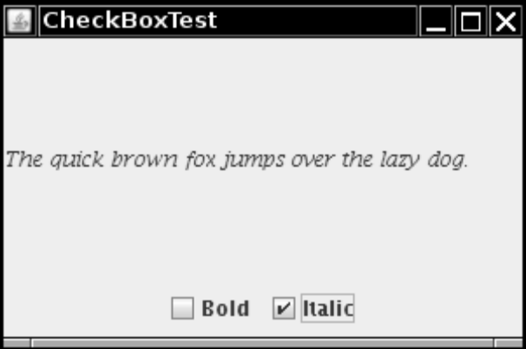

import java.awt.*;
2. import java.awt.event.*;
3. import javax.swing.*;
4.
5. /**
6. * @version 1.33 2007-06-12
7. * @author Cay Horstmann
8. */
9. public class CheckBoxTest
10. {
11. public static void main(String[] args)
12. {
13. EventQueue.invokeLater(new Runnable()
14. {
15. public void run()
16. {
17. CheckBoxFrame frame = new CheckBoxFrame();
18. frame.setDefaultCloseOperation(JFrame.EXIT_ON_CLOSE);
19. frame.setVisible(true);
20. }
21. });
22. }
23. }
24.
25. /**
26. * A frame with a sample text label and check boxes for selecting font attributes.
27. */
28. class CheckBoxFrame extends JFrame
29. {
30. public CheckBoxFrame()
31. {
32. setTitle("CheckBoxTest");
33. setSize(DEFAULT_WIDTH, DEFAULT_HEIGHT);
34.
35. // add the sample text label
36.
37. label = new JLabel("The quick brown fox jumps over the lazy dog.");
38. label.setFont(new Font("Serif", Font.PLAIN, FONTSIZE));
39. add(label, BorderLayout.CENTER);
// this listener sets the font attribute of
42. // the label to the check box state
43.
44. ActionListener listener = new ActionListener()
45. {
46. public void actionPerformed(ActionEvent event)
47. {
48. int mode = 0;
49. if (bold.isSelected()) mode += Font.BOLD;
50. if (italic.isSelected()) mode += Font.ITALIC;
51. label.setFont(new Font("Serif", mode, FONTSIZE));
52. }
53. };
54.
55. // add the check boxes
56.
57. JPanel buttonPanel = new JPanel();
58.
59. bold = new JCheckBox("Bold");
60. bold.addActionListener(listener);
61. buttonPanel.add(bold);
62.
63. italic = new JCheckBox("Italic");
64. italic.addActionListener(listener);
65. buttonPanel.add(italic);
66.
67. add(buttonPanel, BorderLayout.SOUTH);
68. }
69.
70. public static final int DEFAULT_WIDTH = 300;
71. public static final int DEFAULT_HEIGHT = 200;
72.
73. private JLabel label;
74. private JCheckBox bold;
75. private JCheckBox italic;
76.
77. private static final int FONTSIZE = 12;
78. }

